# Steps used to create the Drainage Database file (Scenario 3)

### DEM

* Used the DEM provided by Spence and Hedstrom, 2018

### Preparing the GRU shape files

* Examples: landcover, ecoregion, etc.
  + Used the landcover shapefile from the Spence and Hedstrom (2018) ESSD paper
* Load the files into QGIS using Layer -> add layer -> add vector layer
* Clip to just larger than the desired watershed
* Change the projection to lat/long using Vector -> Data Management Tools -> Reproject Layer (and save the reprojection as a shapefile)
* Change the symbology to group by the ex. landcover type
  + Categorized
  + By GRIDCORE
  + Classify
* 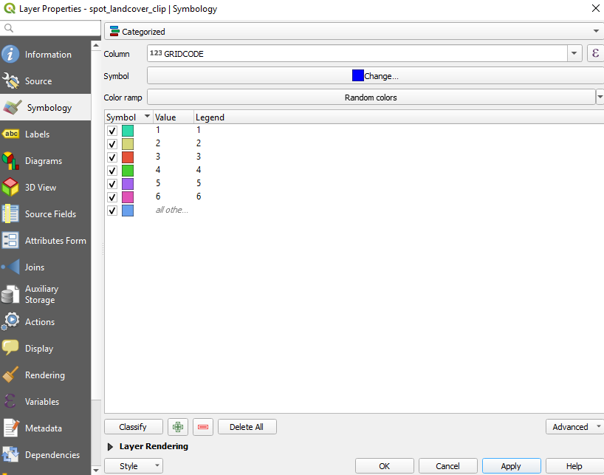
* Try converting to a raster with QGIS -> Raster -> Conversion -> Rasterize (Vector to Raster) and save as a geotiff (.tif file)
  + This is easier to import into Green Kenue
* If can’t convert to a raster, save each category as its own shapefile
  + QGIS -> Edit -> Select -> Select Features by Value
  + Right click on the layer -> Export -> Save Selected Features As
  + Repeat for each landcover feature

### Create the Watershed Object in Green Kenue

* File -> new -> watershed
* Import the DEM
  + File -> import -> Binary raster
  + Assign the co-ordinate system from the “Properties” menu (double-click)
  + 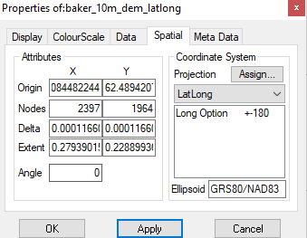
  + Drag the DEM into the DEM spot in the Watershed object
    - From the “Watershed” tab in the properties, click “Generate” to delineate the DEM. This delineates the basin and the channels
      * To compare the channels, try adding a basemap using one of the “rivers and lakes” basemaps from File -> Base Maps
    - It is helpful to change the symbology of the channels to “monochrome” and increase the line weight
  + If the delineation didn’t do a great job of delineating the basin, create a new one by:
    - Select the stream channel object
    - Double-click where you want the outlet to be
    - Right click on the view window, and select “Add Basin”
    - If this is an acceptable delineation, make it the only basin in the watershed object
    - May need to click a little farther downstream to make sure your outlet is included
* Save the watershed file and the basin file
  + Basin as a shape file, watershed as a watershed object

### Create the Map object in Green Kenue

* File -> New -> Watflood Map
* Drag the watershed object into the map object
* Create the Grid
  + Properties -> Map Gen -> select “Fit to User specified delta” and change the delta x and y until you have the number of grid cells you want
  + Click “Collect”
  + Check the drainage directions (change if necessary)
  + 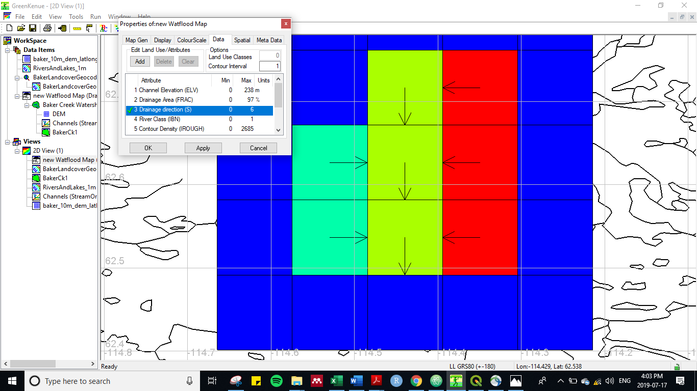
  + 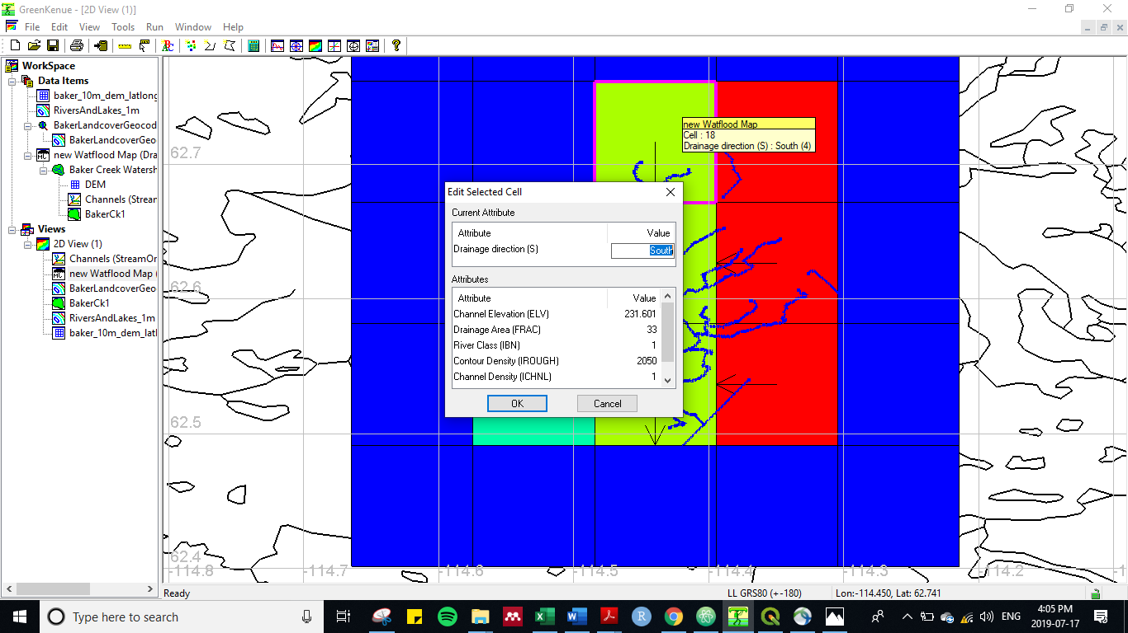
* Import the Landcover
  + File -> Import -> Arcview shapefile
  + Assign the projection (spatial tab of the Properties window)
    - NOTE: if you save your workspace and then re-load it, you will have to re-assign the projection to each shapefile
  + Do this for each layer, if required
* Add the landcover layers to the map file
  + Mapfile Properties -> Data -> Add New Landcover -> Add the name -> Apply
  + Highlight the landcover
    - Tools -> map object -> select shapefile
    - Let it process **This part can take a while (can be up to an hour to assign each)**
  + Repeat for each landcover type
  + Add an “empty” landcover type

### Create the r2c shed file

* Right click the Map File object
* Select “Create Shed from Map”
  + Note: this option doesn’t exist in the online Green Kenue version (need the 3.6 version)
  + This is the most critical step!!
* 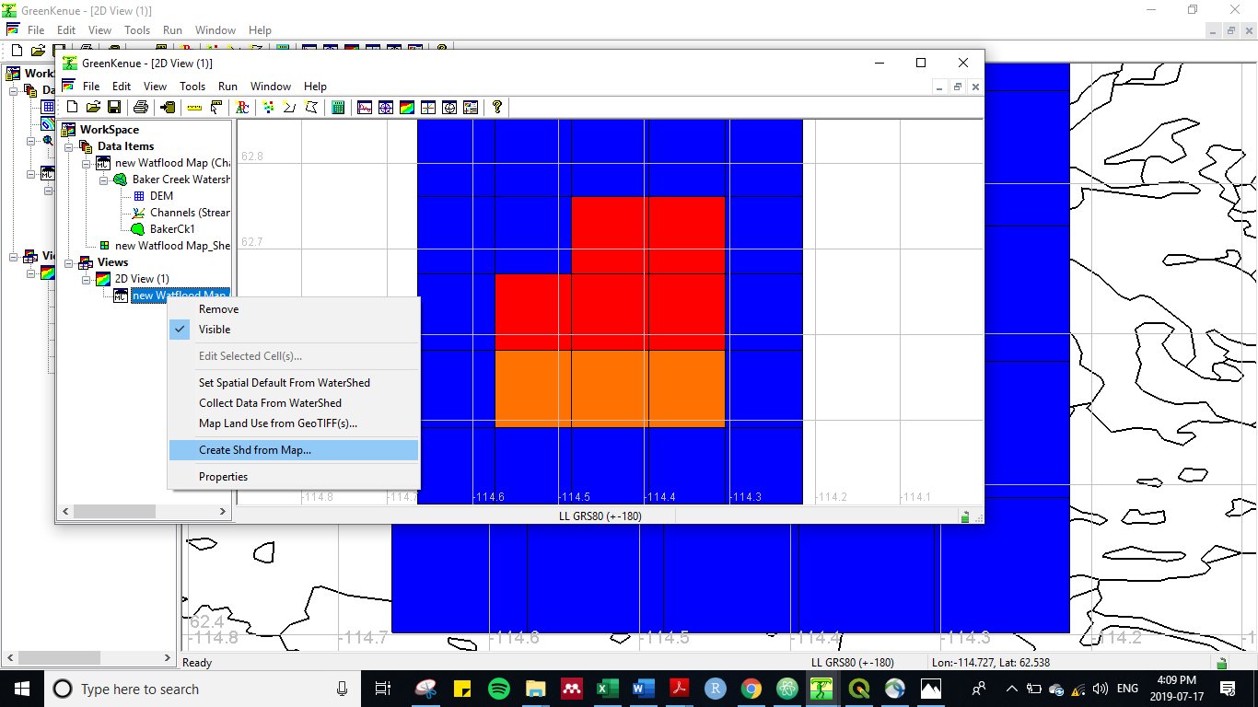

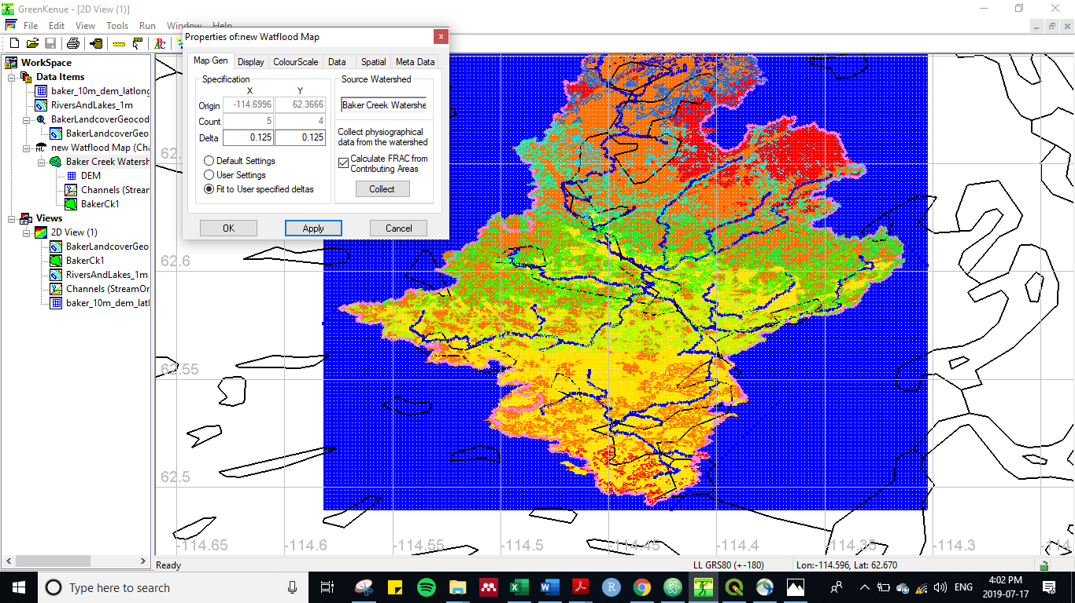

### Summary:

To make the shed file:

* Watershed object
* Map file
  + Make changes to the grid here
  + Re-apply landcover here, but need the watershed object
* R2C file (aka drainage database)
  + Don’t change anything in the r2c file because you can’t go back to use the map file again

GEM/CaPA data

* Send Dan the drainage database file (r2c) and he will extract the data for that domain

If using a geotiff (raster of the landcover info), use the

* UTM: distance is in meters; lat/long: distance is in degrees, which must be converted to distance based on the location on the earth